More than Toys Project Guideline
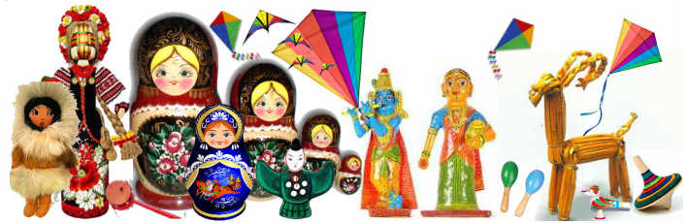
1.Lead in
Toys must have come into being at the earliest stages of civilization.They are easy to make and safe to play. But they are more than toys. As an indispensable part of traditional folk art, they are a unique expression of a long national history, national spirit and cultural continuity. Religious beliefs, world view, taste, classical works and local customs, are all represented in ethnic toys by the use of various techniques requiring an artisans' deepest wisdom and creativity.
The advantage is that the greater majority of people can enjoy the pleasure of folk toys that are easier to make and more widely available than other artistic works, as they tend to utilize common articles that are always available, such as cloth, grass, straw, clay, paper, and so on. Even so, it should be noted that these toys are not of a coarse manufacture, but of rustic simplicity and vivacity.
It is believed that there is a healing aspect to making the dolls, that doing handicrafts and creating useful and beautiful things help to balance the nervous system and improve mood. Creating these toys can be a fun and relaxing way to spend time and, once you get the hang of it, a very satisfying and beautiful one.

2. Brief one-sentence description of project:
Students research and share the information about their national toys, including the instructions on how to create themfor the partners to learn from the findings of the peers in other parts of the world and to make their school collections of handmade toys.
3. Full description of project:
- Step 1: students use different sources, including parents, grandparents, other families and other members of community surveying, questioning, interviewing, to find out the information about their various national folk dolls/toys concerning the history and origin, materials they are usually made of, interesting facts/folk songs/poems about them, believes or superstitions connected with them, etc. Once students are through with their research they make the presentations of their work to the partner schools using MS Word/PP/Publisher/blog/video/email.
- Step 2: students make their folk toys using the simplest materials such as paper, threads, straw or even plastic bottles and get ready the image, photo, video, PP instructions on how to make them as well as a special doll/toy’s message of love, respect, friendship etc. and share it with their partners.
- Step 3: fallowing partner’s instructions and making as many similar toys as they like, the partner students then share the results of their work in a virtual gallery and present the dolls/toys and their messages at school performances.
4. Age/level of project participants:
5-16 years
5. Timetable/Schedule for the project (please provide dates):
Each step up to 2 months any time during the year:
Step 1: October-November
Step 2: December-January
Step 3: February-March:

6. Possible project/classroom activities:
online search, recording the researched material using MS word/publisher/PP/blog/video messages etc. and sharing it with the partner schools on the online forum, creating handmade toys.
7. Expected outcomes/products:
- A virtual gallery of national folk dolls/toys of different countries,
- Publication of all materials sent by students on aweb page
- Organization of an exhibition of works of participants
8. Project language(s):
English
9. Curriculum/Subject area:
History,Local History, ICT, Arts and Crafts, Social Studies and Language.

